GOVERNMENT OF KARNATAKA / KEONICS
Information Security & Access Control Evidences
Target Application: Examination Management Portal
Cross-Reference Application: BDA RTI Management Portal | Audit Scope: HDFC Section 3 Identity & Access Management Review
Application Name | Examination Management Portal (KEONICS / Government of Karnataka)
Companion System | BDA RTI Management Portal (Bangalore Development Authority)
Audit Standard | HDFC Information Security Review — Section 3: User Access & Identity Controls
Technology Stack | React 19 Frontend, Spring Boot REST API, MySQL 8.x Database, MinIO Object Storage, Redis

1. Audit Evidence Summary & Compliance Matrix
Sl. No. | Audit Evidence Item | Application Name | Status / Response | Screenshot / Evidence Ref
1 | New user onboarding | Examination Management Portal | Available | Figure 1: Persons Management & Figure 2: Roles
2 | User deprovisioning | Examination Management Portal | Available | Figure 3: Post & Designation Unmapping
3 | Privilege access review | Examination Management Portal | Available | Figure 4: Role-Permissions Matrix (30+ Controls)
4 | Third-party user access review | Examination Management Portal | Not applicable | Zero vendor direct access; isolated API integration
5 | Password policy settings (AD / IAM) | Examination Management Portal | Available | Figure 5: Staff Login & Complexity / Lockout Specs
6 | Password change / forgot password screen | Examination Management Portal | Available | Figure 6: Candidate OTP & Figure 7: Forgot Password
7 | Password expiry & change notification | Examination Management Portal | Available | Automated SMS Gateway alerts (sms_audit table)

2. Evidence 1: New User Onboarding
Application Name | Examination Management Portal
Audit Checklist Item | Sl. No. 1 — Available (screenshot of user creation and role assignment)
Underlying Database Entities | users, personal_details, roles, user_roles, posts, post_person_mappings, ctr_user_binding
New staff, administrators, and examination centre personnel are provisioned through a centralized administrative console. The system enforces strict onboarding workflows: an administrator creates the staff profile with mandatory fields (employee ID, official email, verified mobile, department, and designation), assigns one or more system roles (Super Admin, Examination Admin, Centre Admin, Invigilator), and maps the user to an administrative post and authorized examination centre.

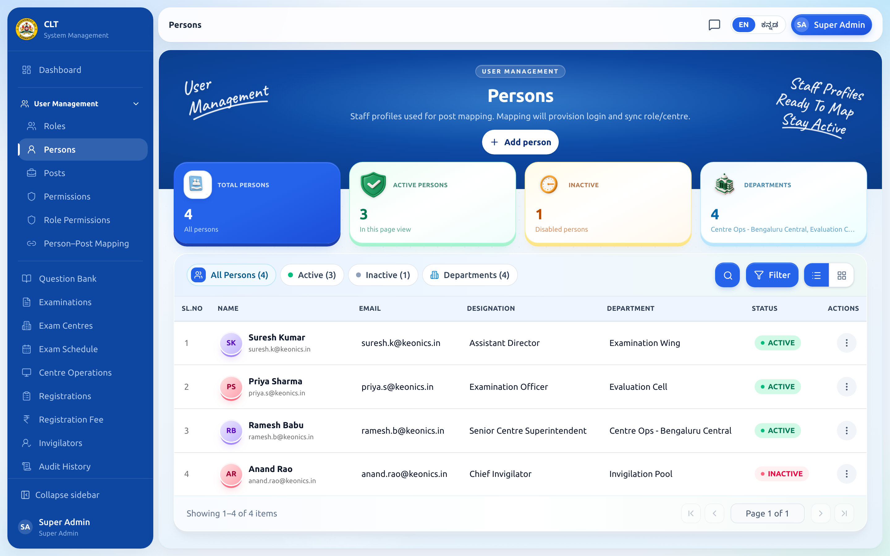
Figure 1: Examination Management Portal — Staff User Management & Onboarding Console (/admin/persons)

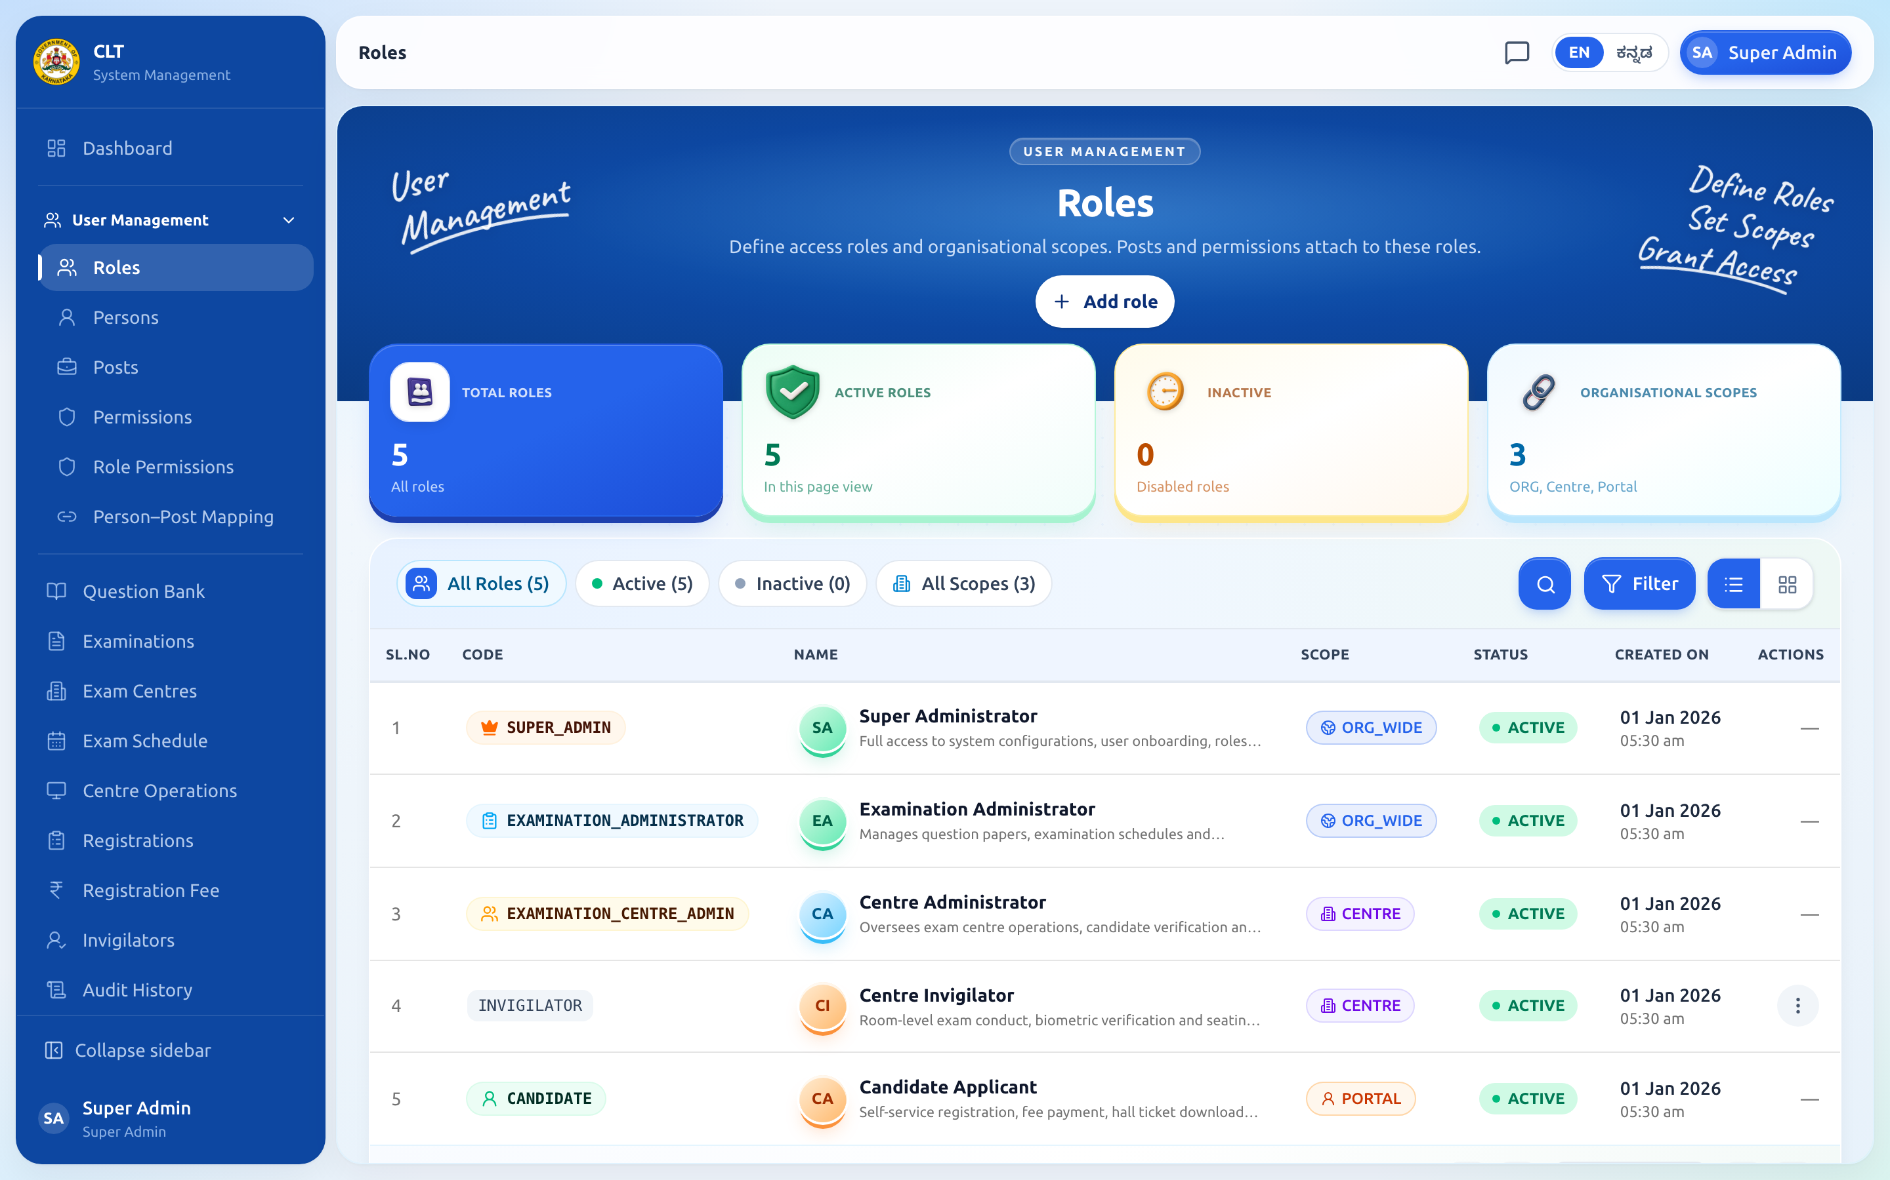
Figure 2: Examination Management Portal — Role Assignment & System Scope Configuration (/admin/roles)

3. Evidence 2: User Deprovisioning
Application Name | Examination Management Portal
Audit Checklist Item | Sl. No. 2 — Available (screenshot of user deactivation and post unmapping)
Underlying Database Entities | users (status=INACTIVE), post_person_mappings (unmap_reason), ctr_user_binding, audit_events
When personnel are transferred, retire, or no longer require system access, deprovisioning is executed immediately. Deprovisioning comprises: (1) Setting user status to 'INACTIVE' in the users and personal_details tables (as demonstrated by inactive profile records); (2) Unmapping the person from their administrative post with a recorded reason (unmap_reason in post_person_mappings); (3) Deactivating centre bindings in ctr_user_binding; and (4) Instant blacklisting and eviction of active JWT session tokens from Redis cache. The complete operation is recorded with actor ID, timestamp, and audit trail in audit_events.

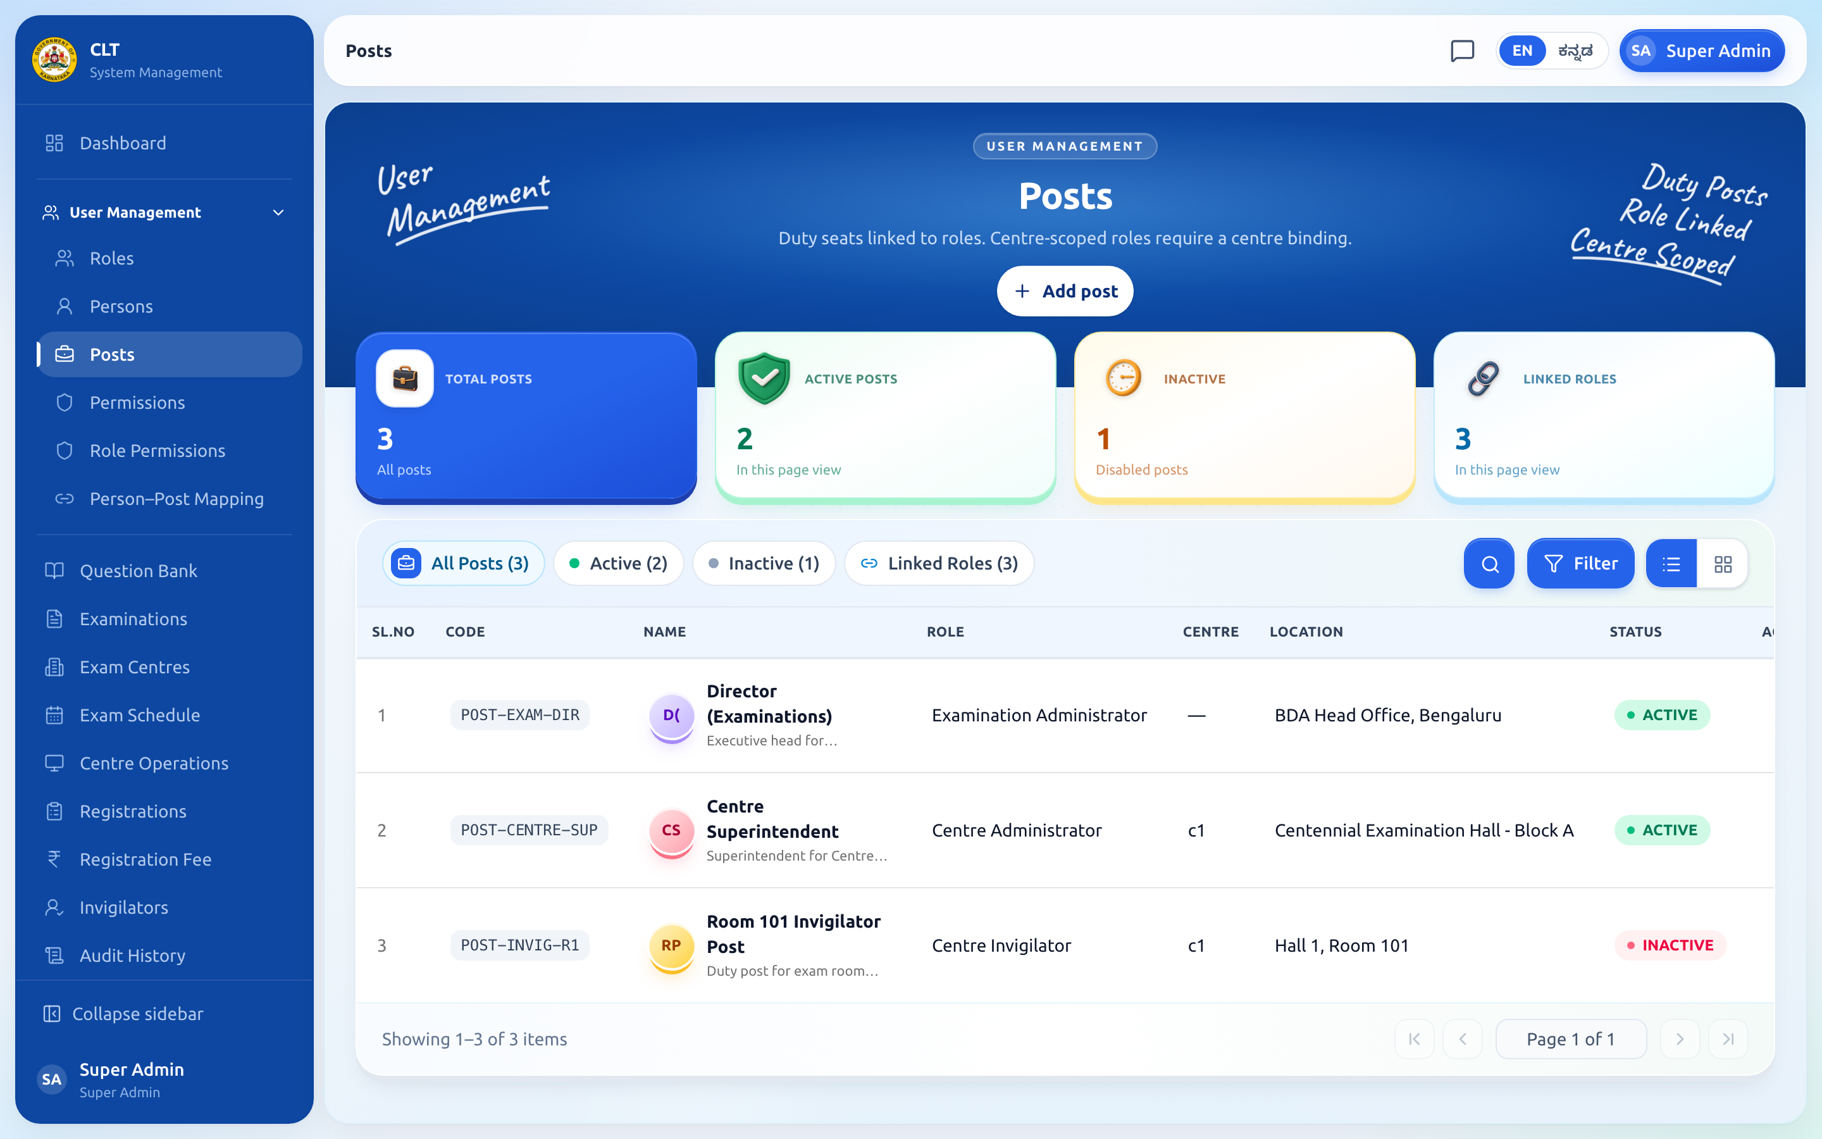
Figure 3: Examination Management Portal — Administrative Post Deallocation & Deprovisioning Console (/admin/posts)

4. Evidence 3: Privilege Access Review
Application Name | Examination Management Portal
Audit Checklist Item | Sl. No. 3 — Available (Role-Permissions Matrix & Granular Access Control)
Underlying Database Entities | roles, permissions, role_permissions, audit_events
The Examination Management Portal implements granular Role-Based Access Control (RBAC). Over 30 discrete permissions (e.g., PERSON:MANAGE, ROLE:MANAGE, QUESTION:MANAGE, SCHEDULE:MANAGE, OPS:ACTIVATION:MANAGE) are mapped to predefined system roles. Privilege access reviews are performed by reviewing the centralized Role-Permissions matrix, ensuring principle of least privilege. Any alteration to permissions is captured in audit_events for compliance review.

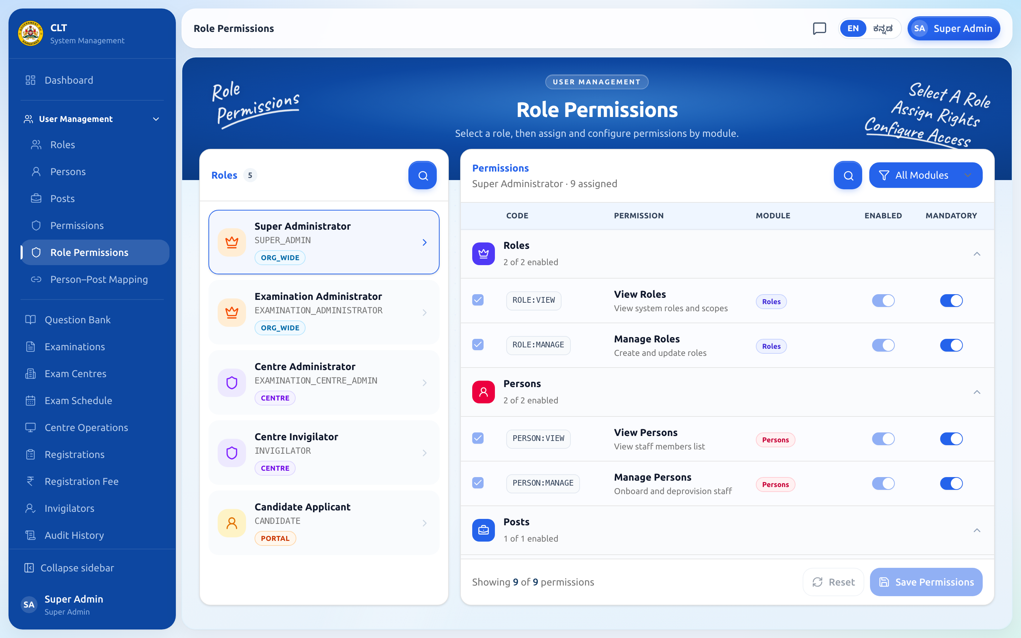
Figure 4: Examination Management Portal — Granular Role-Permissions Matrix Review (/admin/role-permissions)

5. Evidence 4: Third-Party User Access Review
Application Name | Examination Management Portal & BDA RTI Portal
Audit Checklist Item | Sl. No. 4 — Not applicable. Vendors and third parties do not have access to our systems or client applications.
Underlying Database Entities | N/A (Architecture isolation policy enforced via network firewall and Spring Security filters)
Formal Declaration:
• Zero External Vendor Accounts: External software vendors, contractors, and third parties do not possess user accounts, credentials, or remote VPN access to the Examination Management Portal or BDA RTI Portal databases.
• Strict Boundary & API Isolations: External entities (e.g., PayU payment gateway, Karnataka Mobile Seva SMS gateway, and KGID KYE service) communicate exclusively via automated, machine-to-machine HTTPS REST API endpoints secured with client authentication tokens, IP allowlists, and strict timeouts (5s connect / 15s read).
• Database Protection: Database access is restricted to localhost/private subnet application pools; direct external database connections are disabled.

6. Evidence 5: Password Policy Settings (AD / IAM / Portal)
Application Name | Examination Management Portal
Audit Checklist Item | Sl. No. 5 — Available (Examination Portal password and lockout settings)
Underlying Database Entities | users (failed_login_attempts, lockout_until), auth_login_captcha, cand_otp_policy, cand_otp_challenge
The portal enforces comprehensive password security and brute-force mitigation controls directly in application security configurations:
• Password Length & Complexity: 10 to 16 characters, requiring at least one uppercase letter, one lowercase letter, one digit, and one special character.
• Secure Cryptographic Storage: Passwords stored exclusively as BCrypt salted hashes (10-12 work factor rounds). Zero plain-text storage.
• Account Lockout Threshold: Account locked for 30 minutes after 5 consecutive failed login attempts (tracked in users.failed_login_attempts and users.lockout_until).
• Cryptographic Captcha: Mandatory challenge-response captcha (auth_login_captcha) on staff login to thwart automated brute-force attacks.
• Candidate OTP Security: 6-digit numeric OTP sent via SMS, valid for 300 seconds, with lockout after 5 failed attempts (cand_otp_policy).

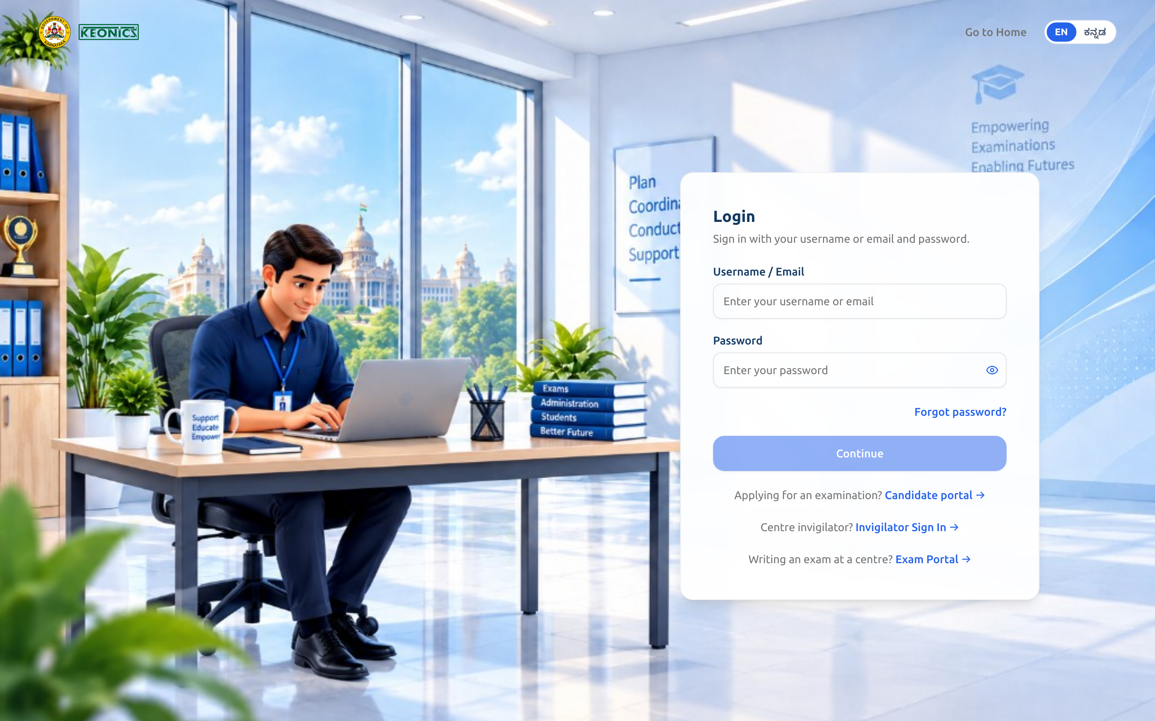
Figure 5: Examination Management Portal — Staff Login Portal with Captcha Protection (/login)

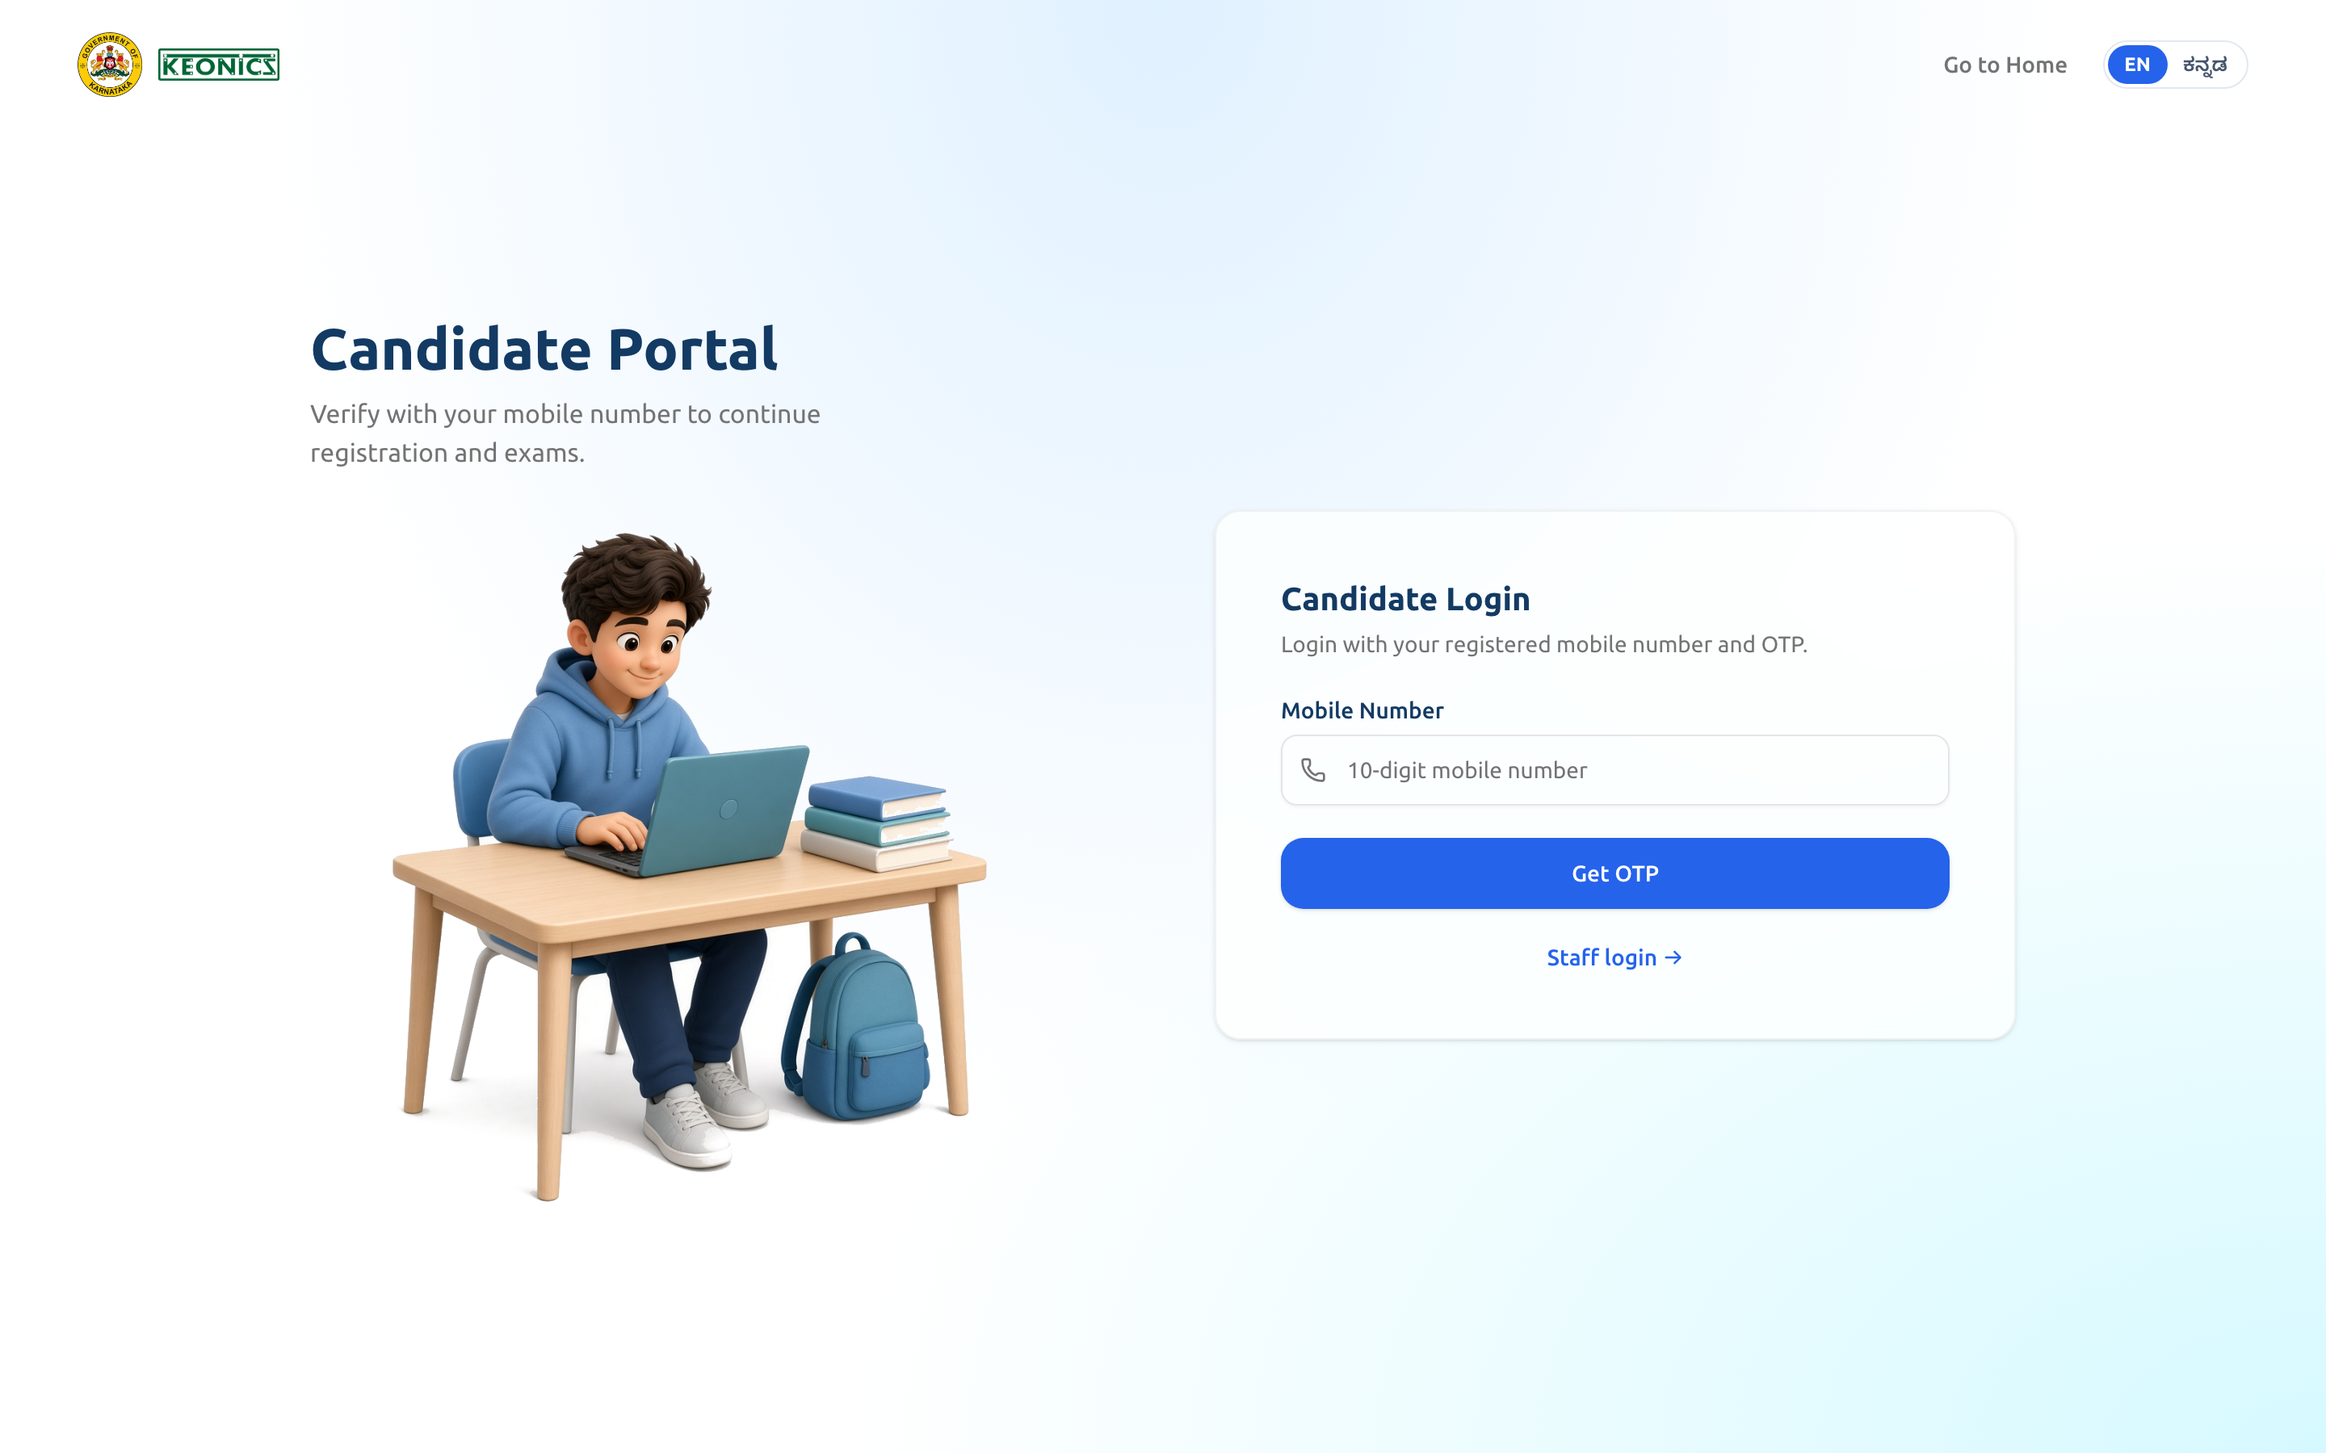
Figure 6: Examination Management Portal — Candidate OTP Login & Policy Verification (/candidate/login)

7. Evidence 6: Password Change / Forgot Password Screen
Application Name | Examination Management Portal
Audit Checklist Item | Sl. No. 6 — Available (screenshots)
Underlying Database Entities | users (change_password_required, last_password_changed_at), auth_login_captcha
The portal provides self-service password recovery and mandatory first-time password rotation:
• Forgot Password Workflow: Multi-step verification requiring registered Login ID/Email, one-time OTP delivered to registered mobile/email, and new password confirmation complying with complexity standards.
• Mandatory First-Time Password Change: Flag users.change_password_required forces staff to change system-assigned initial passwords before gaining application access.
• Session Invalidation: Resetting password invalidates all existing sessions, requiring fresh authentication.


Figure 7: Examination Management Portal — Forgot Password & Two-Step Verification Dialog

8. Evidence 7: Reminder for Password Expiry & Change Notification
Application Name | Examination Management Portal
Audit Checklist Item | Sl. No. 7 — Available (Automated SMS & System Notifications)
Underlying Database Entities | sms_template, sms_audit, audit_events
Password change confirmations, security alerts, and OTP lifecycle events are automatically dispatched to the user's registered mobile number via the Karnataka Mobile Seva SMS gateway.
• Template Control: DLT-registered templates defined in sms_template table.
• Audit Log: Every transmitted security notification is permanently logged in sms_audit with timestamp, delivery status, masked mobile number, and gateway response.

